Program-1: Write a JavaScript to design a simple calculator to perform the following operations: sum, product, difference and quotient.

Sathiya_Priya_S 1JT18IS051

<html>

<head>

<h1><center>A SIMPLE CACULATOR PROGRAM</center></h1>

<script>

function dis(val)

{

document.getElementById("result").value+=val

}

function solve()

{

let x = document.getElementById("result").value

let y = eval(x)

document.getElementById("result").value = y

}

function clr()

{

document.getElementById("result").value = ""

}

</script>

<!-- for styling -->

<style>

text-align:center;

width: 100%;

}

table{

margin-left:auto;

margin-right:auto;

background-color:grey;

}

table, th, td {

border: 2px solid white;

background: grey;

}

th {

height: 50px;

}

tr

{

height:50px;

}

input[type="button"]

{

background-color:grey;

color: black;

border: solid grey 2px;

height:50px;

width:100%

}

input[type="text"]

{

background-color:grey;

border: solid grey 1px;

height:50px;

width:100%

}

</style>

</head>

<!-- create table -->

<body>

<div class = title ></div>

<table border="1">

<tr>

<td colspan="3"><input type="text" id="result"/></td>

<!-- clr() function will call clr to clear all value -->

</tr>

<tr>

<!-- create button and assign value to each button -->

<!-- dis("1") will call function dis to display value -->

<td><input type="button" value="1" onclick="dis('1')"/> </td>

<td><input type="button" value="2" onclick="dis('2')"/> </td>

<td><input type="button" value="3" onclick="dis('3')"/> </td>

<td><input type="button" value="/" onclick="dis('/')"/> </td>

</tr>

<tr>

<td><input type="button" value="4" onclick="dis('4')"/> </td>

<td><input type="button" value="5" onclick="dis('5')"/> </td>

<td><input type="button" value="6" onclick="dis('6')"/> </td>

<td><input type="button" value="*" onclick="dis('*')"/> </td>

</tr>

<tr>

<td><input type="button" value="7" onclick="dis('7')"/> </td>

<td><input type="button" value="8" onclick="dis('8')"/> </td>

<td><input type="button" value="9" onclick="dis('9')"/> </td>

<td><input type="button" value="-" onclick="dis('-')"/> </td>

</tr>

<tr>

<td><input type="button" value="c" onclick="clr()"/> </td>

<td><input type="button" value="0" onclick="dis('0')"/> </td>

<!-- solve function call function solve to evaluate value -->

<td><input type="button" value="=" onclick="solve()"/> </td>

<td><input type="button" value="+" onclick="dis('+')"/> </td>

</tr>

</table>

</body>

</html>

Output:

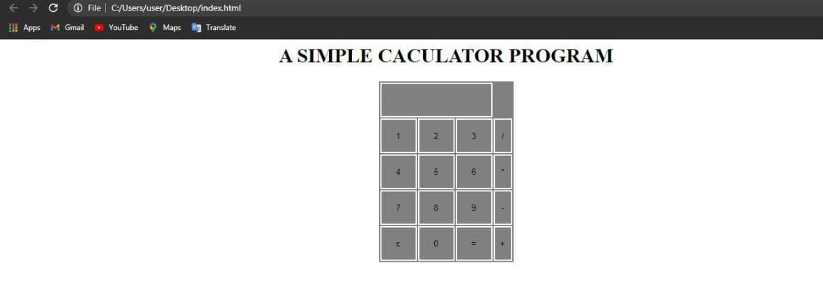

Test Case:

|  |  |  |  |  |
| --- | --- | --- | --- | --- |
| Test No. | Input Parameter | Expected Output | Obtained Output | Remark |
| 1 | Value1: 10  Value2: 5 | Addition: 15  Subtraction: 5  Multiplication: 50  Division: 2 | Addition: 15  Subtraction: 5  Multiplication: 50  Division: 2 | Pass |
| 2 | Value1: 1.5  Value2: 2.5 | Addition: 4  Subtraction: -1  Multiplication: 3.75  Division: 0.6 | Addition: 4  Subtraction: -1  Multiplication: 3.75  Division: 0.6 | Pass |
| 3 | Value1: 0  Value2: 10 | Addition: 10  Subtraction: -10  Multiplication: 0  Division: 0 | Addition: 10  Subtraction: -10  Multiplication: 0  Division: 0 | Pass |
| 4 | Value1: -1  Value2: -2 | Addition: -3  Subtraction: 1  Multiplication: 2  Division: 0.5 | Addition: -3  Subtraction: 1  Multiplication: 2  Division: 0.5 | Pass |
| 5 | Value1: 10  Value2: 0 | Addition: 10  Subtraction: 10  Multiplication: 0  Division: Infinity | Addition: 10  Subtraction: 10  Multiplication: 0  Division: Infinity | Pass |